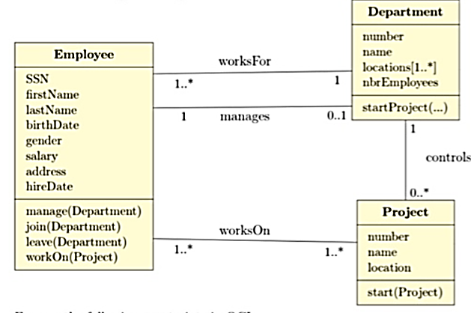
Projects
Projects
department
department
PEmployees
Manager
DEmployees

- Precondition for the startProject of a department is that it has at least 5 employees in including a manager.
- The SSN of each employee is unique
- Total number of employees in a department are equal to the sum of all employees working on different projects controlled by that department.
- The post condition for join(Department) is that nbrEmployees is increased by 1 and dEmployees is also updated.
- The location of the project belongs to the locations of its concerned department.

